Evaluation: Random Forest
Accuracy: 0.9203539823008849
Precision: 0.9571269438526075
Recall: 0.9203539823008849
F1 Score: 0.9293307472374273
Jaccard Index: 0.8803477217140352
Matthews CorrCoef: 0.905532110808832
Cohen’s Kappa: 0.8988055591656378
Specificity: 0.9889655607845069
AUC: 1.0
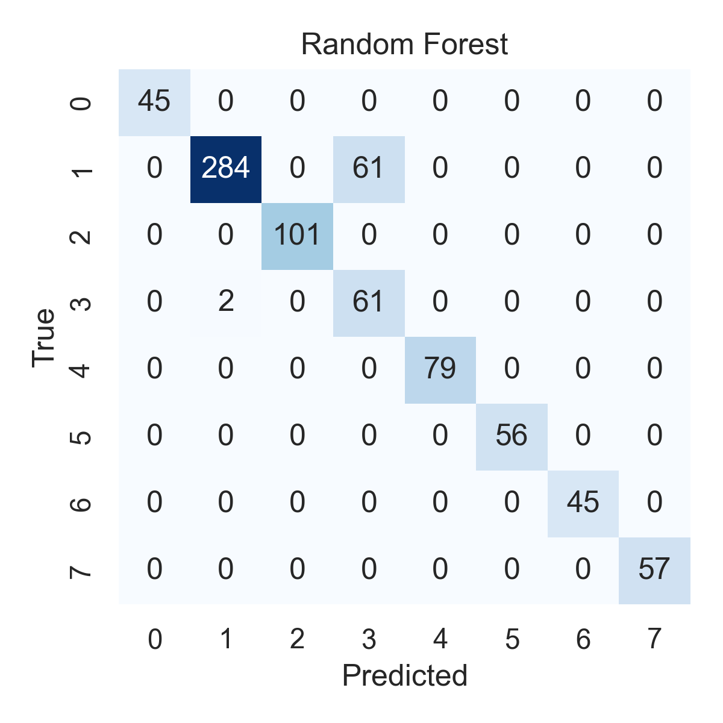

Combined ROC Curves
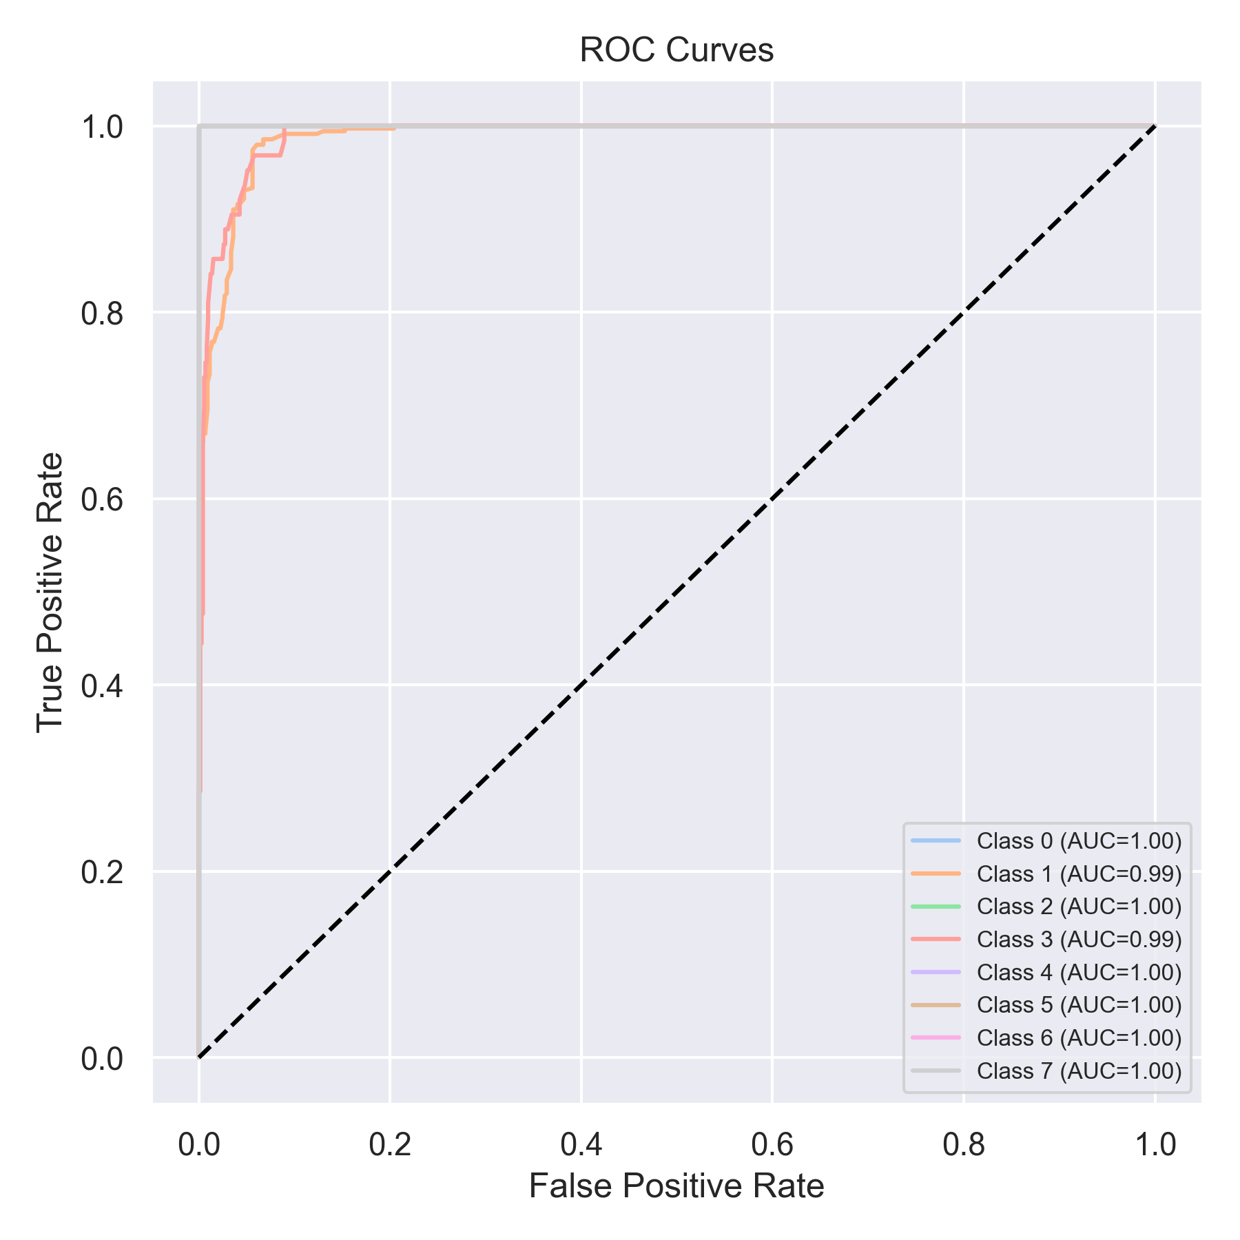

Evaluation: K-Nearest Neighbors
Accuracy: 0.6814159292035398
Precision: 0.7431717850750572
Recall: 0.6814159292035398
F1 Score: 0.6768744551983801
Jaccard Index: 0.5150270002499994
Matthews CorrCoef: 0.6347041043734357
Cohen’s Kappa: 0.6162012915747277
Specificity: 0.9542162098630113
AUC: 0.980161575601128
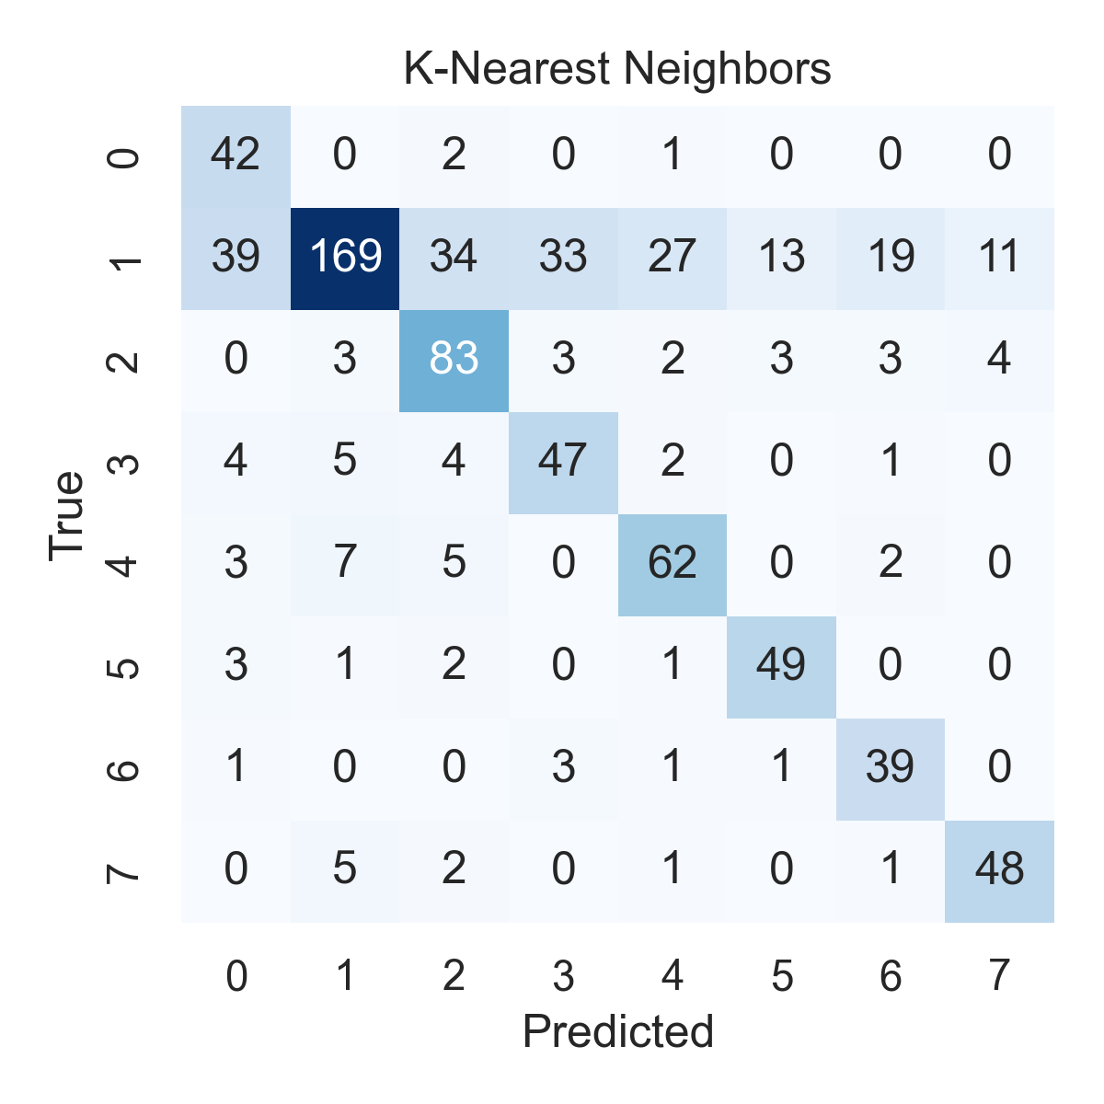

Combined ROC Curves
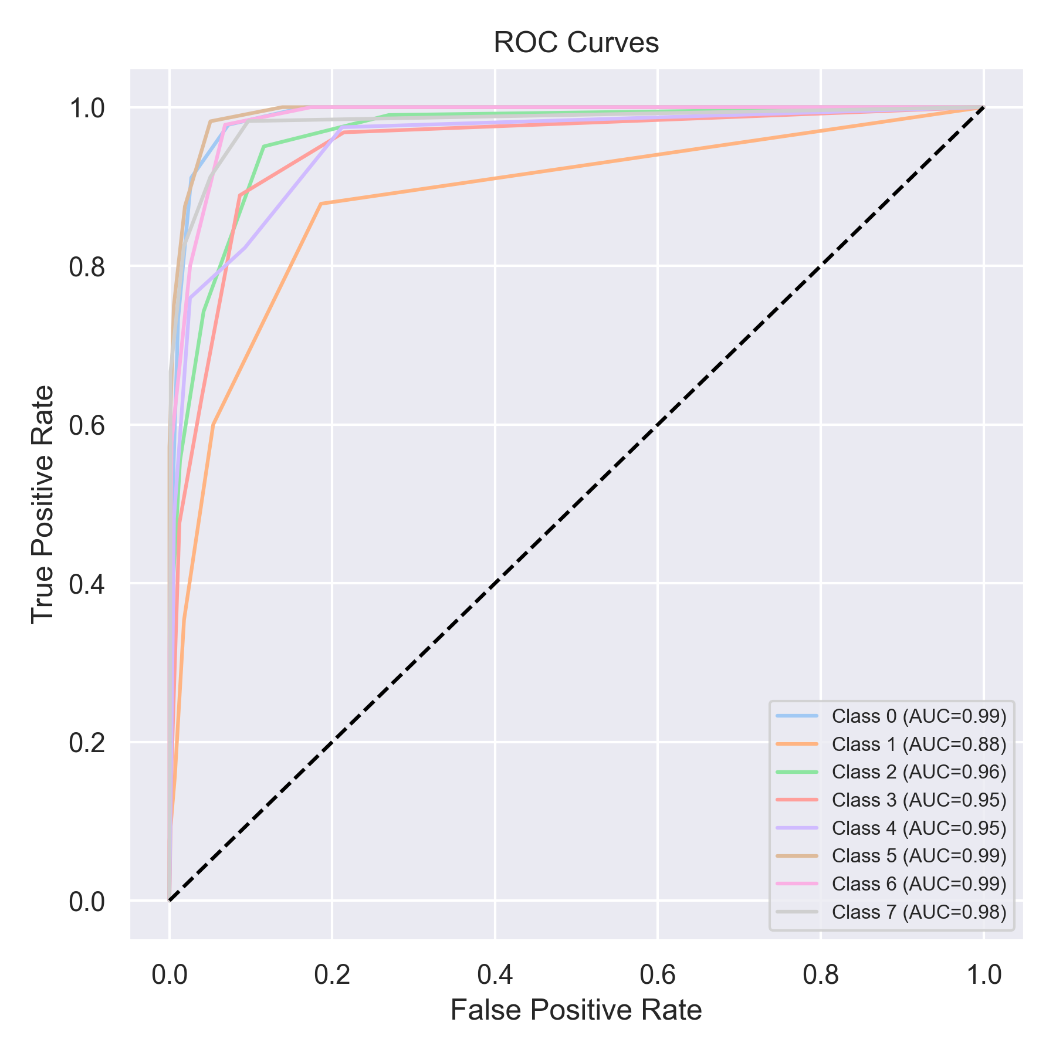

Evaluation: Decision Tree
Accuracy: 0.7332490518331226
Precision: 0.8670130109565951
Recall: 0.7332490518331226
F1 Score: 0.7683896074485466
Jaccard Index: 0.6853398479262984
Matthews CorrCoef: 0.711001317228998
Cohen’s Kappa: 0.6783908462374459
Specificity: 0.9606221973094171
AUC: 1.0
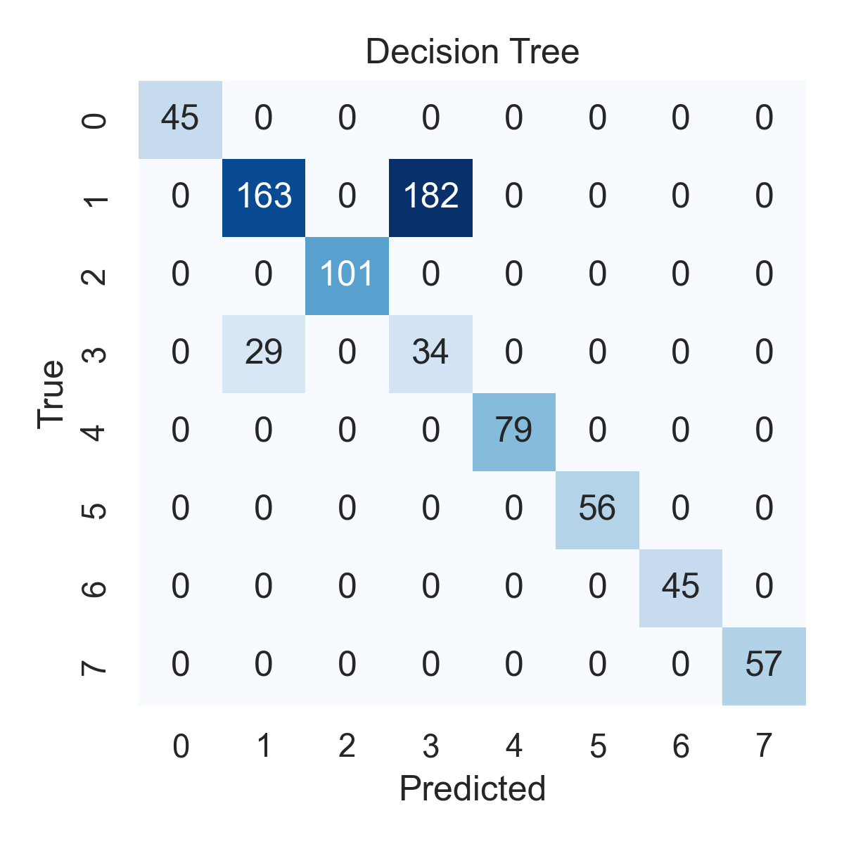

Combined ROC Curves
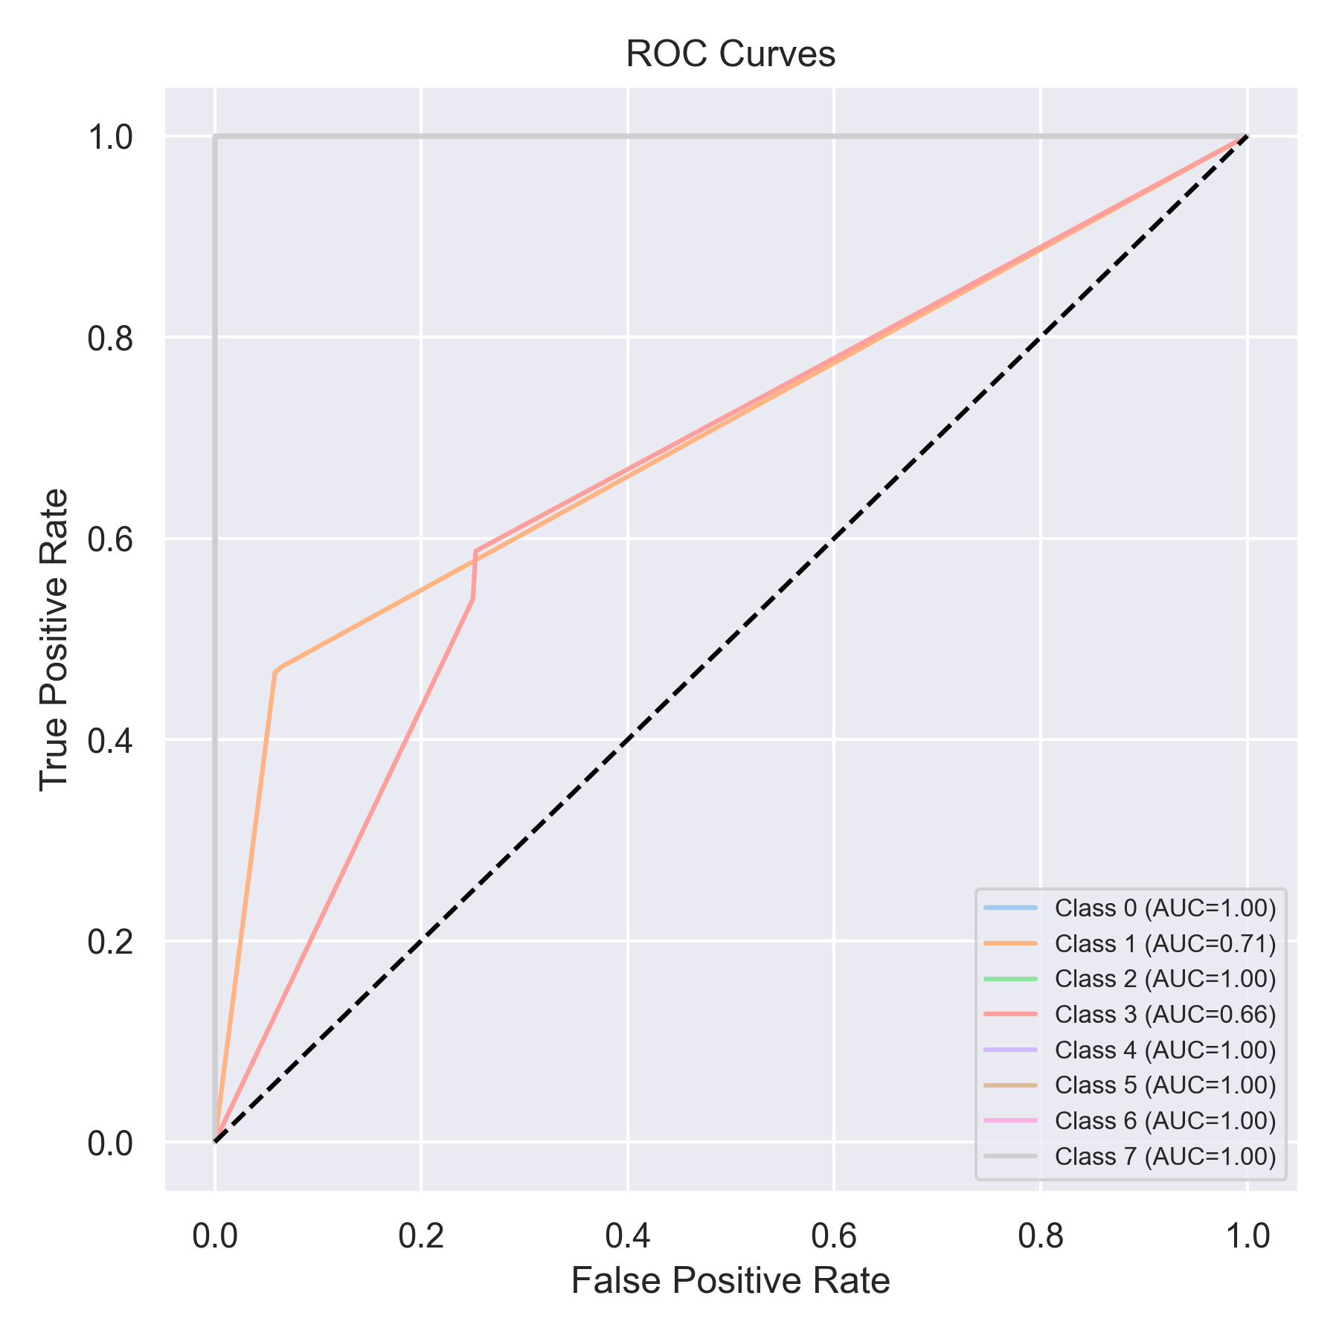

Evaluation: Extra Trees
Accuracy: 0.9810366624525917
Precision: 0.9825241761523518
Recall: 0.9810366624525917
F1 Score: 0.9814452797519482
Jaccard Index: 0.964889930828771
Matthews CorrCoef: 0.9753581169423173
Cohen’s Kappa: 0.9751962454662333
Specificity: 0.9971003885341649
AUC: 1.0000000000000002
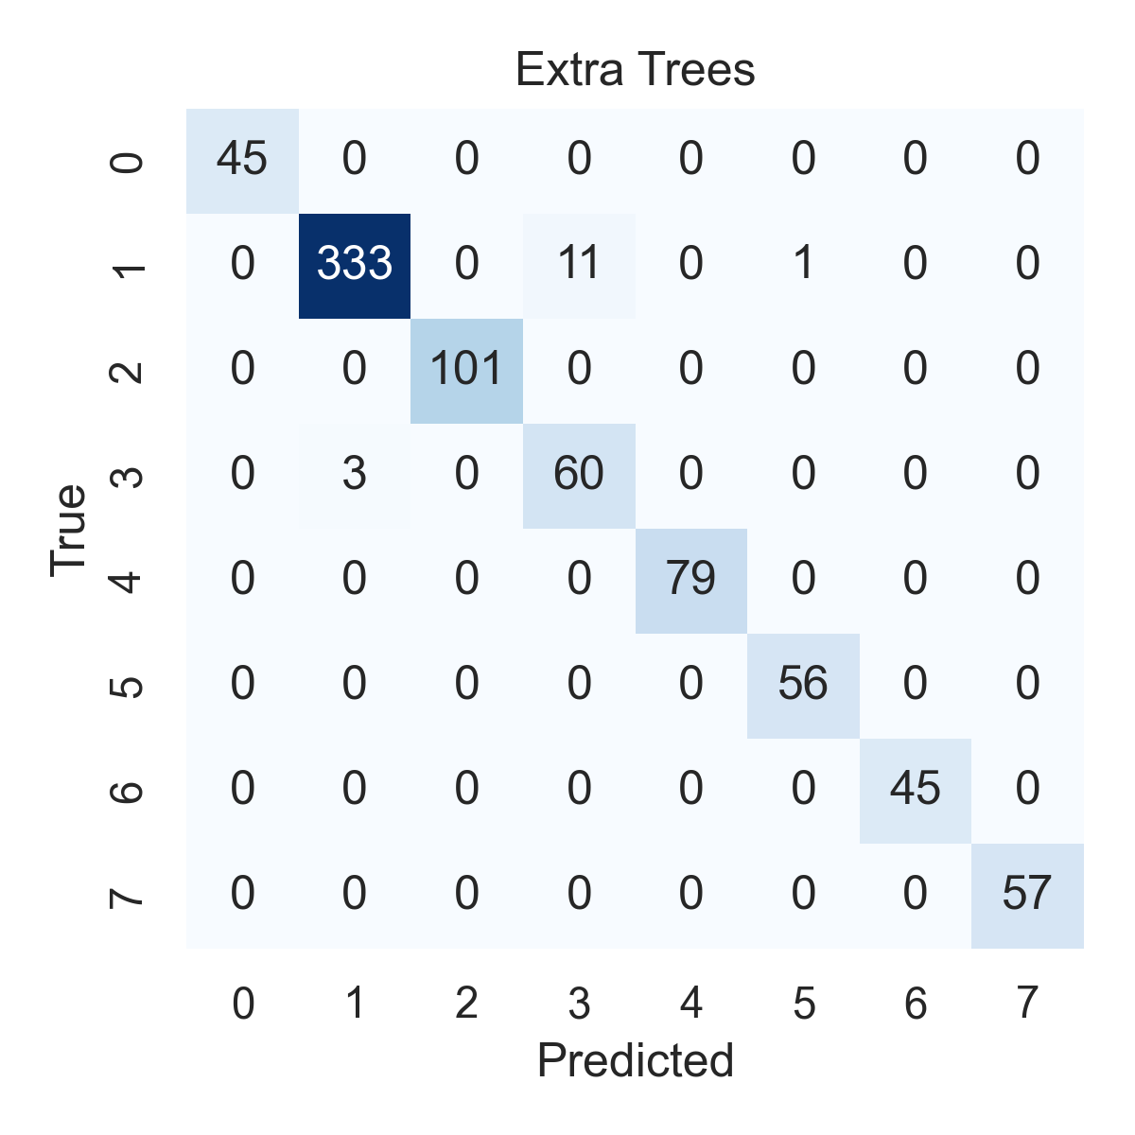

Combined ROC Curves
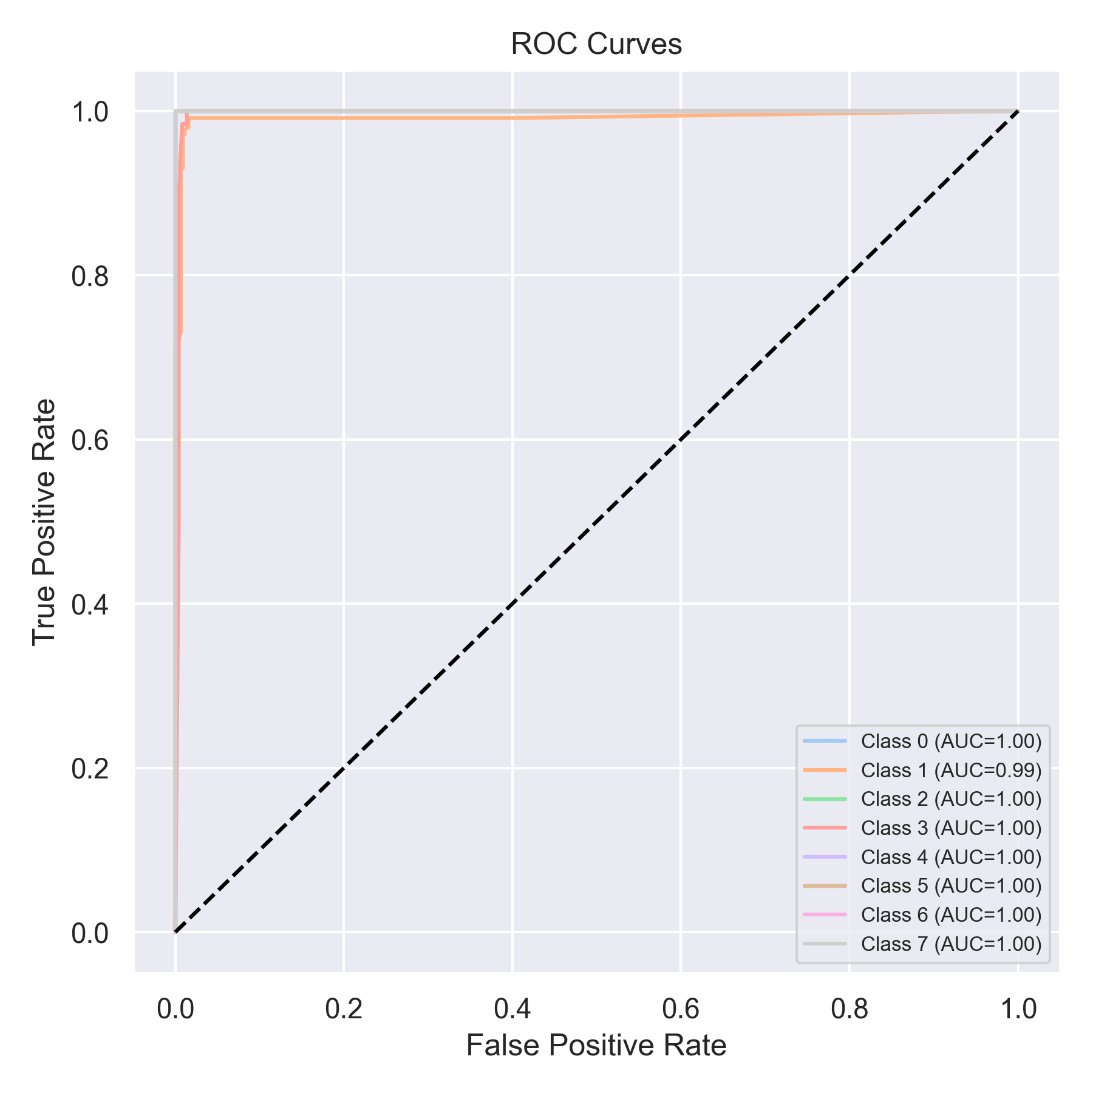

Evaluation: Bagging Classifier
Accuracy: 0.7307206068268015
Precision: 0.8680654216805601
Recall: 0.7307206068268015
F1 Score: 0.7657553663453878
Jaccard Index: 0.6825289572334617
Matthews CorrCoef: 0.7102388217393965
Cohen’s Kappa: 0.6760465617092624
Specificity: 0.9603873564776031
AUC: 1.0
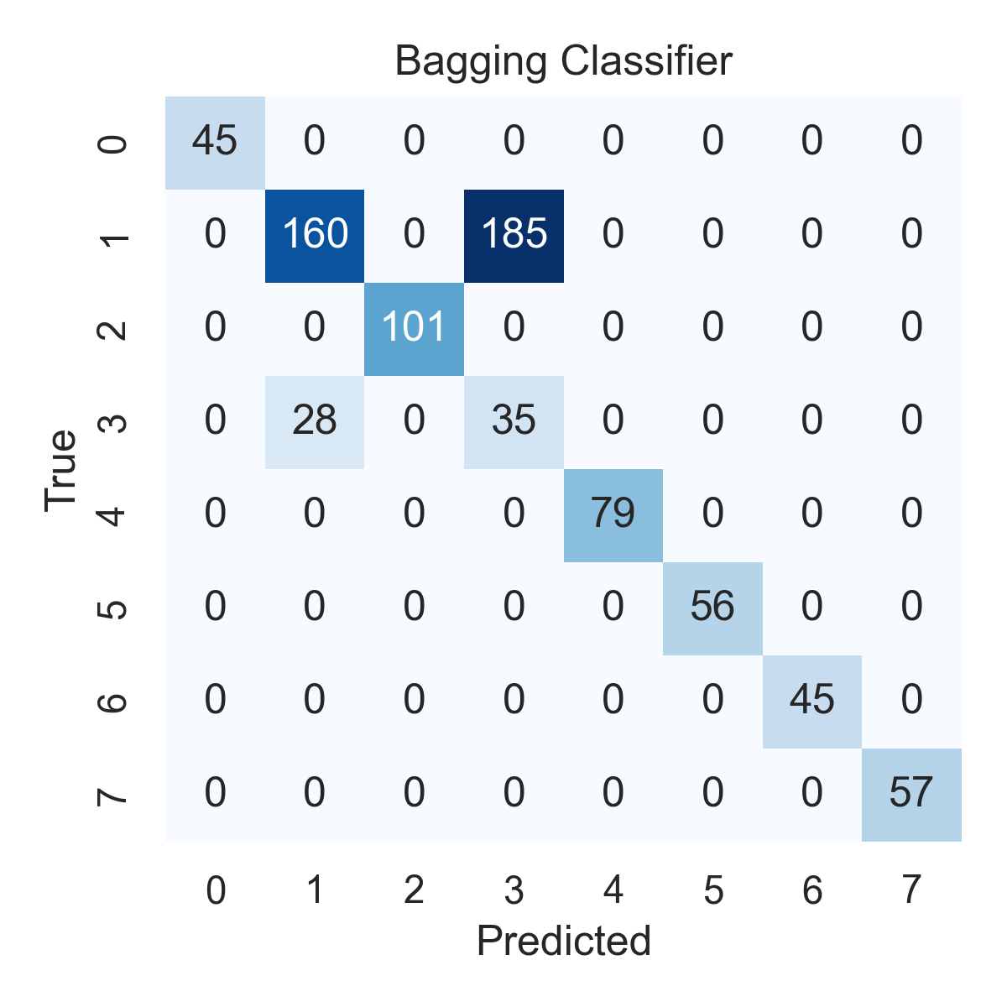

Combined ROC Curves
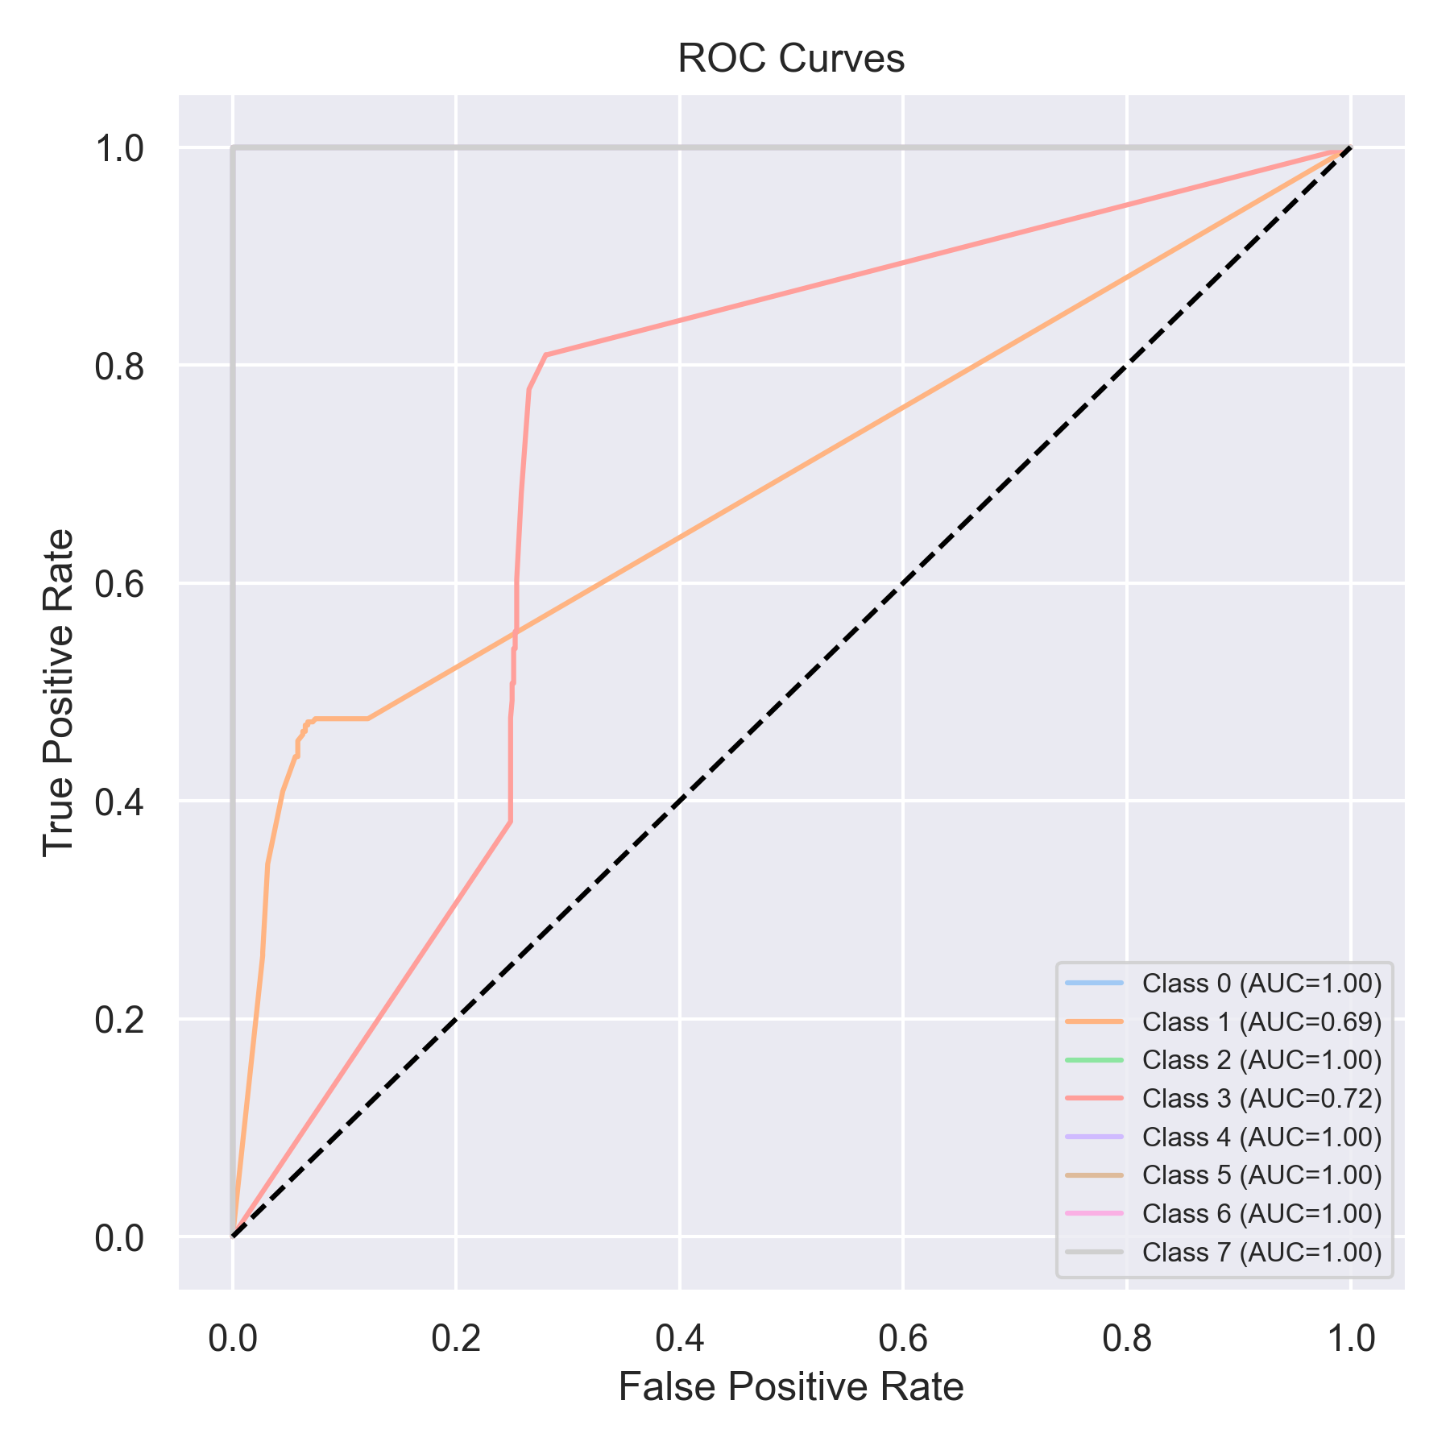

Evaluation: XGBoost
Accuracy: 0.7395701643489254
Precision: 0.8824331101946074
Recall: 0.7395701643489254
F1 Score: 0.7728637512929548
Jaccard Index: 0.6887563384582862
Matthews CorrCoef: 0.7245321418749162
Cohen’s Kappa: 0.6875400292237304
Specificity: 0.9622406741240822
AUC: 1.0
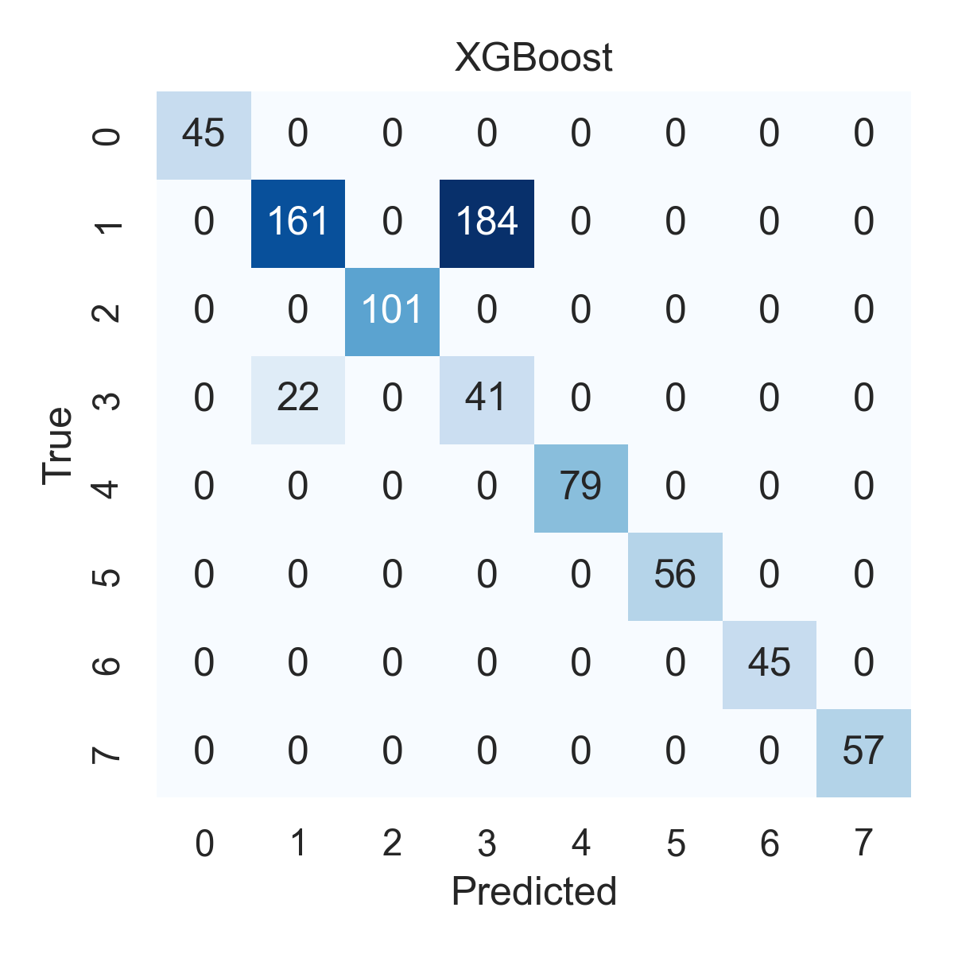

Combined ROC Curves
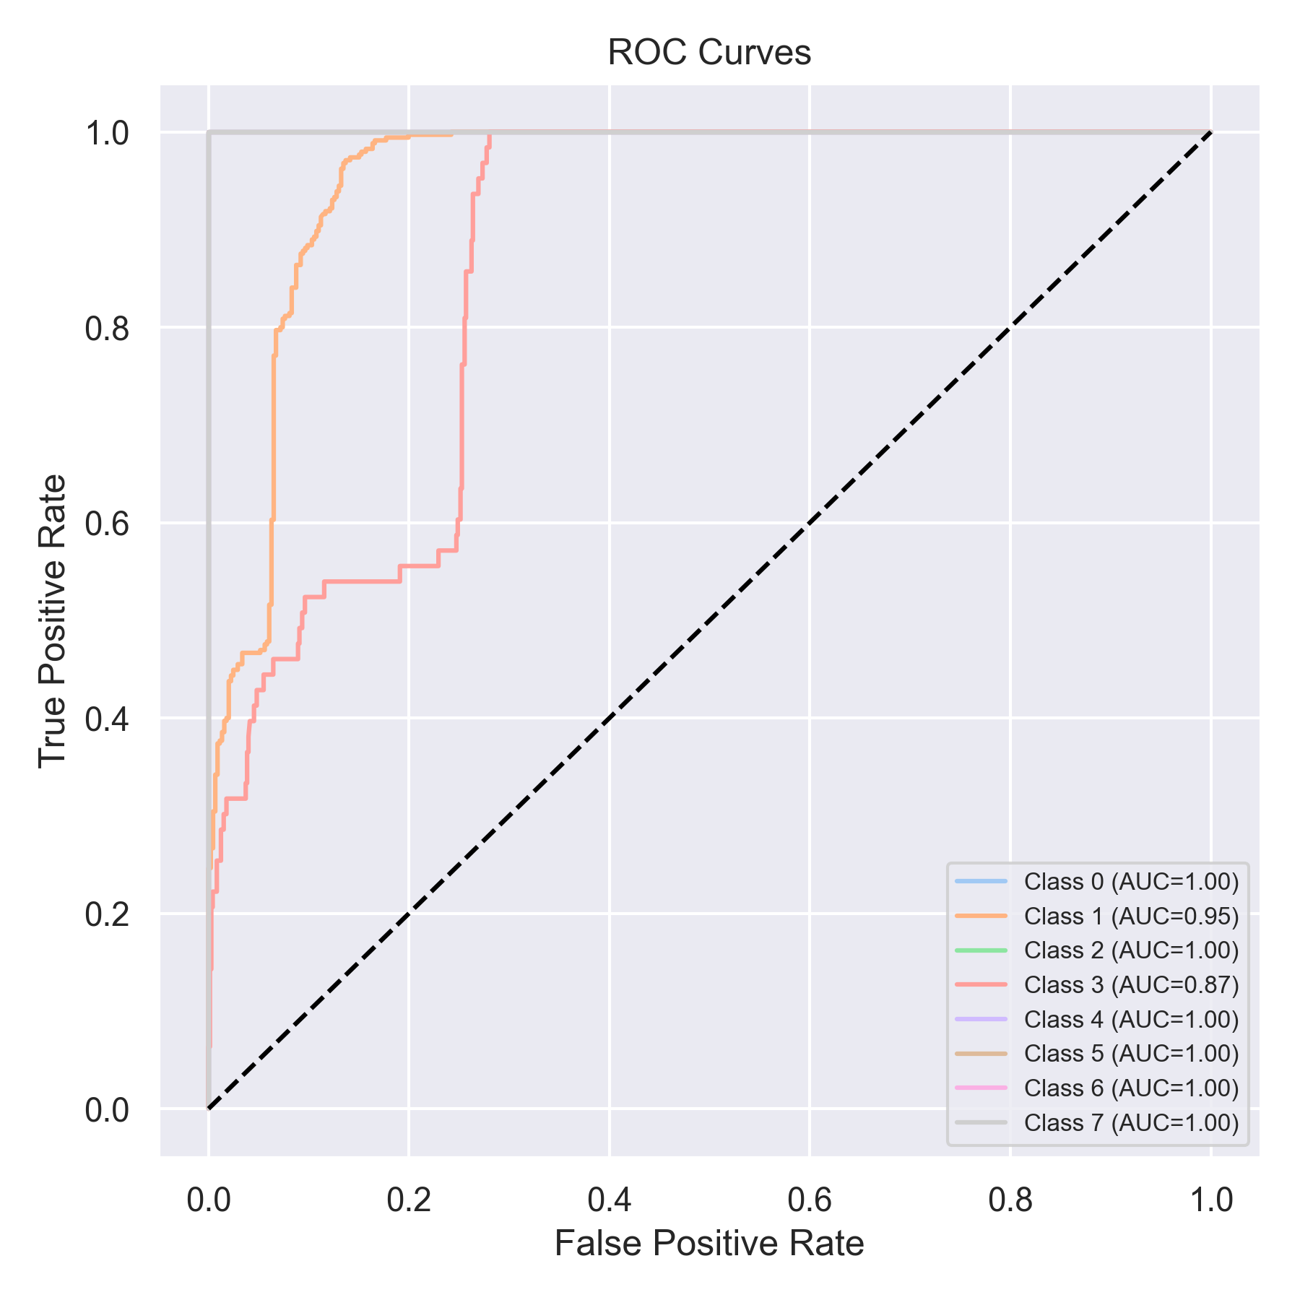

Evaluation: LightGBM
Accuracy: 0.7749683944374209
Precision: 0.8895948872266958
Recall: 0.7749683944374209
F1 Score: 0.8059179775980657
Jaccard Index: 0.7240008002876397
Matthews CorrCoef: 0.7516664560329069
Cohen’s Kappa: 0.7255581501420958
Specificity: 0.9669398006701818
AUC: 1.0
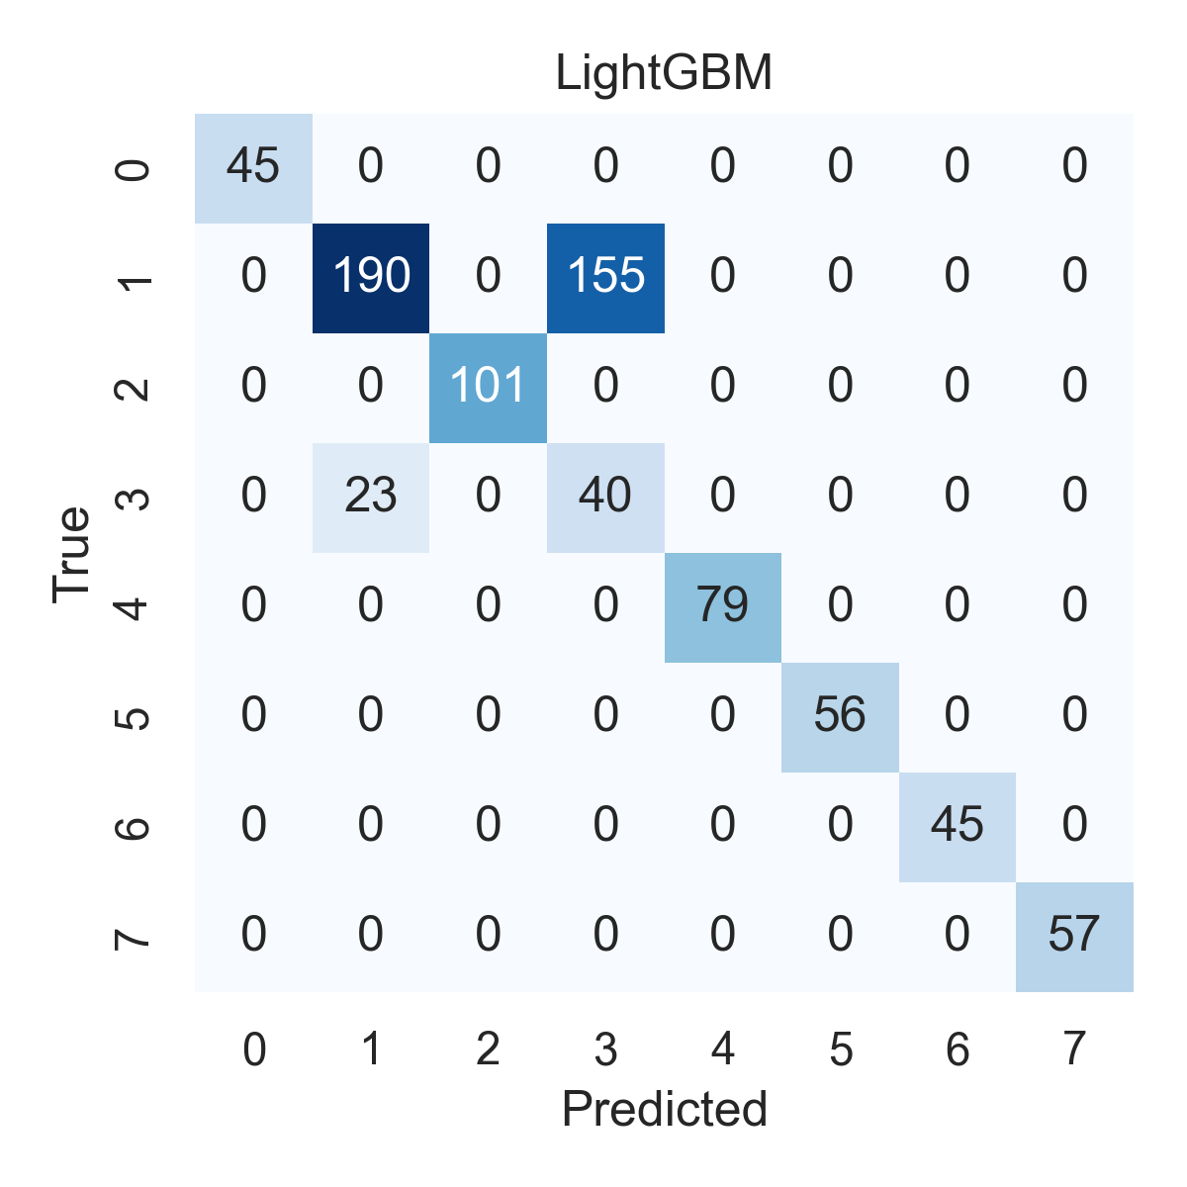

Combined ROC Curves
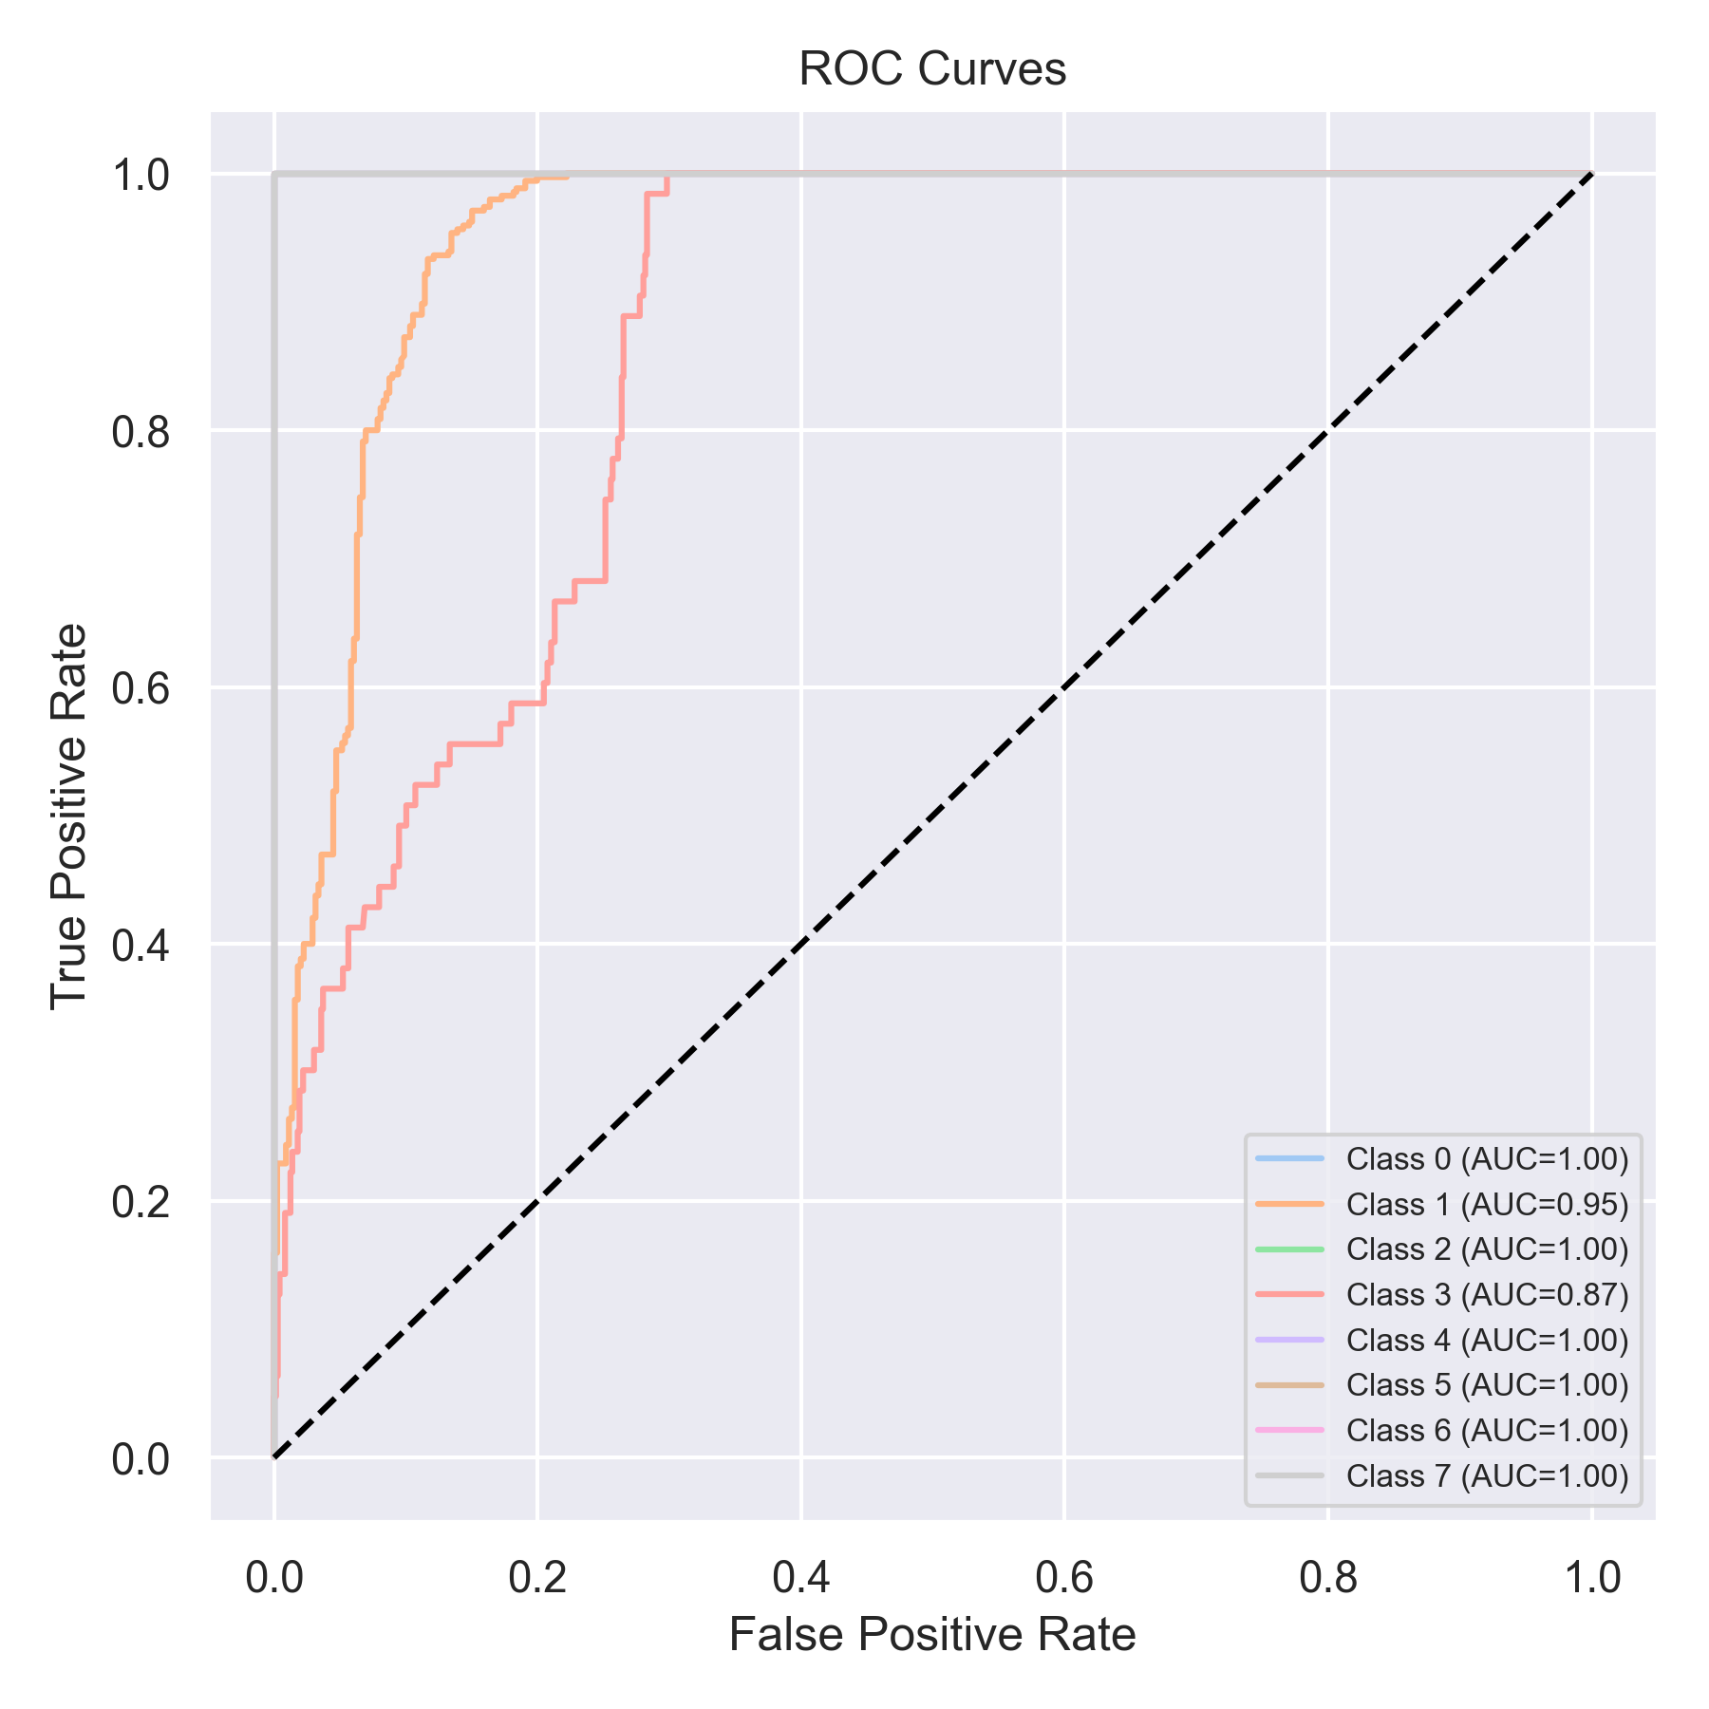

Evaluation: CatBoost
Accuracy: 0.056890012642225034
Precision: 0.003236473538432524
Recall: 0.056890012642225034
F1 Score: 0.006124522892105566
Jaccard Index: 0.003236473538432524
Matthews CorrCoef: 0.0
Cohen’s Kappa: 0.0
Specificity: 0.875
AUC: 1.0
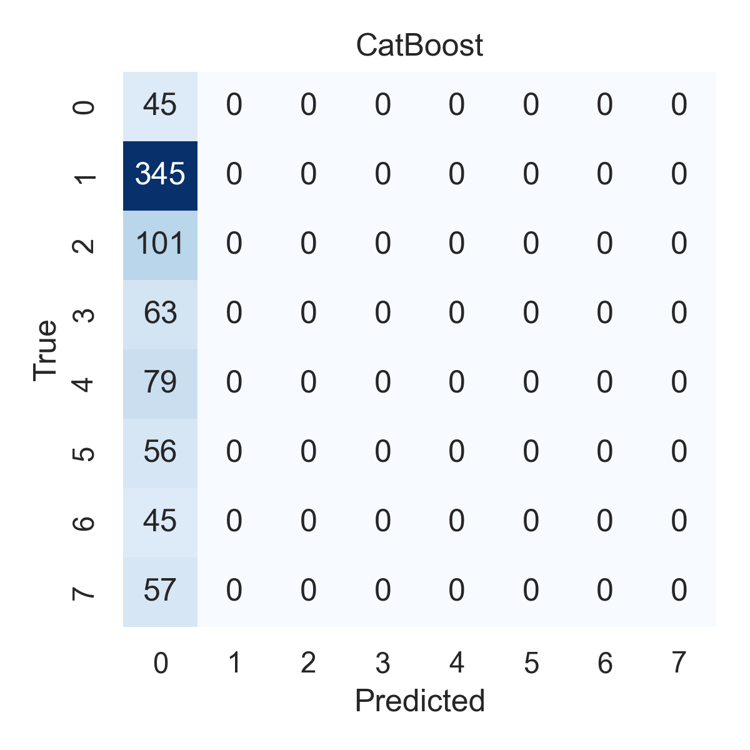

Combined ROC Curves
